Obesity Classification Report

In this report we will be attempting to predict and classify a person’s obesity status based on a given dataset. We will also go over a brief exploratory data analysis to get a better understanding of the data we are working with. As well as determining the best model and technique that can predict and classify a person’s obesity status.
Before proceeding with the exploratory data analysis segment, a keynote to mention is that the following columns were the most promising based on the multivariate analysis and feature importance selection.
- Weight
- family_history_with_overweight
- Age
- daily_water_drinking
- food_between_meals
- Height
- Gender or Gender_Female
- daily_vegetable_consumption

Exploratory Data Analysis
In this segment we will be analyzing the dataset to get a better understanding of what columns will aid in classifying a person’s obesity. We will also look for any potential anomalies such as missing data or duplicated data that can hinder our progress. Also, we will analyze the data for an y patterns that can help is exploit to prep our data for our models to better learn with.

Initial Data Analysis
This section analyzes the initial values and statistics of our dataset as well as whether our dataset contains empty values and duplicates. Figure 1 shows us what values we are dealing with. We have a mixture of categorical, binary and numerical values. We can also see based on Figure 2 the statistics of the numerical columns.
Figure 1 Dataset initial overview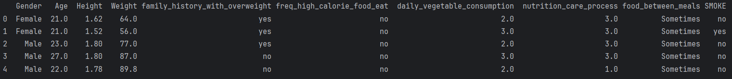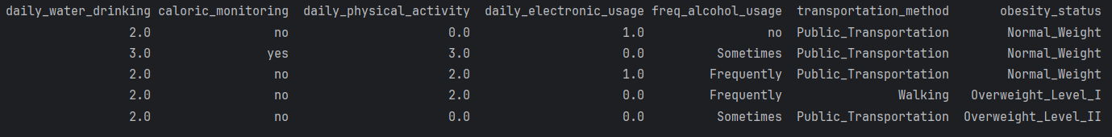
Figure 2 Dataset Statistics
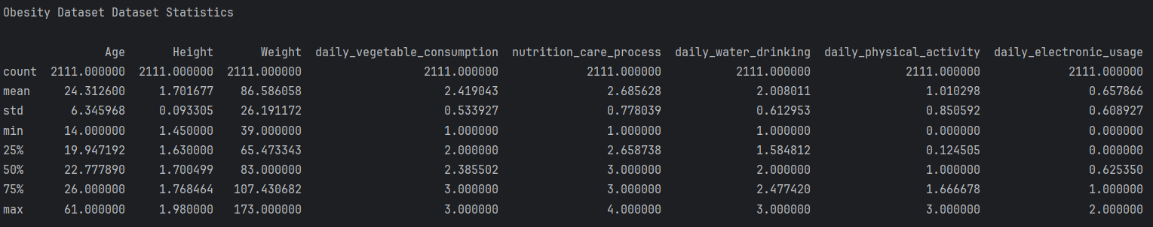
Figure 3 shows us key information about our dataset. We can see whether these columns have missing values or not. Based on the shape of the dataset we can compare the row value of 2111 and the non-null count column. It indicates that each column has 2111 non-null values indicating each column has no missing values.
Figure 3: Checking Dataset for null values
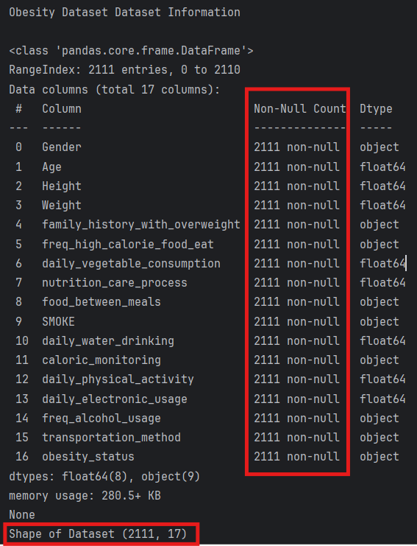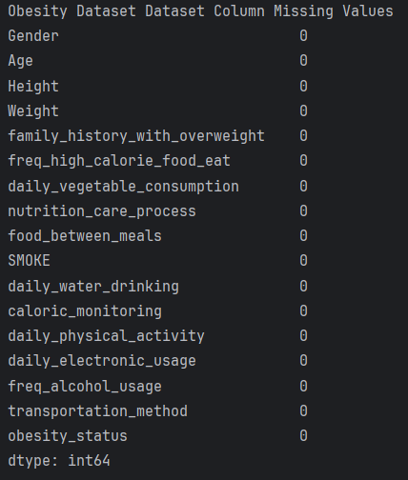

Univariate Column Analysis
This section analyzes each column individually. We will also be viewing the numerical and categorical data columns separately. Starting off with Figure 4 we have histograms of our numerical columns. There is a clear distinction in which numerical columns follow a distribution that include Height, Weight, and Age. The rest are abnormal, indicating the values are spread out.
Figure 4 Histogram of numerical columns
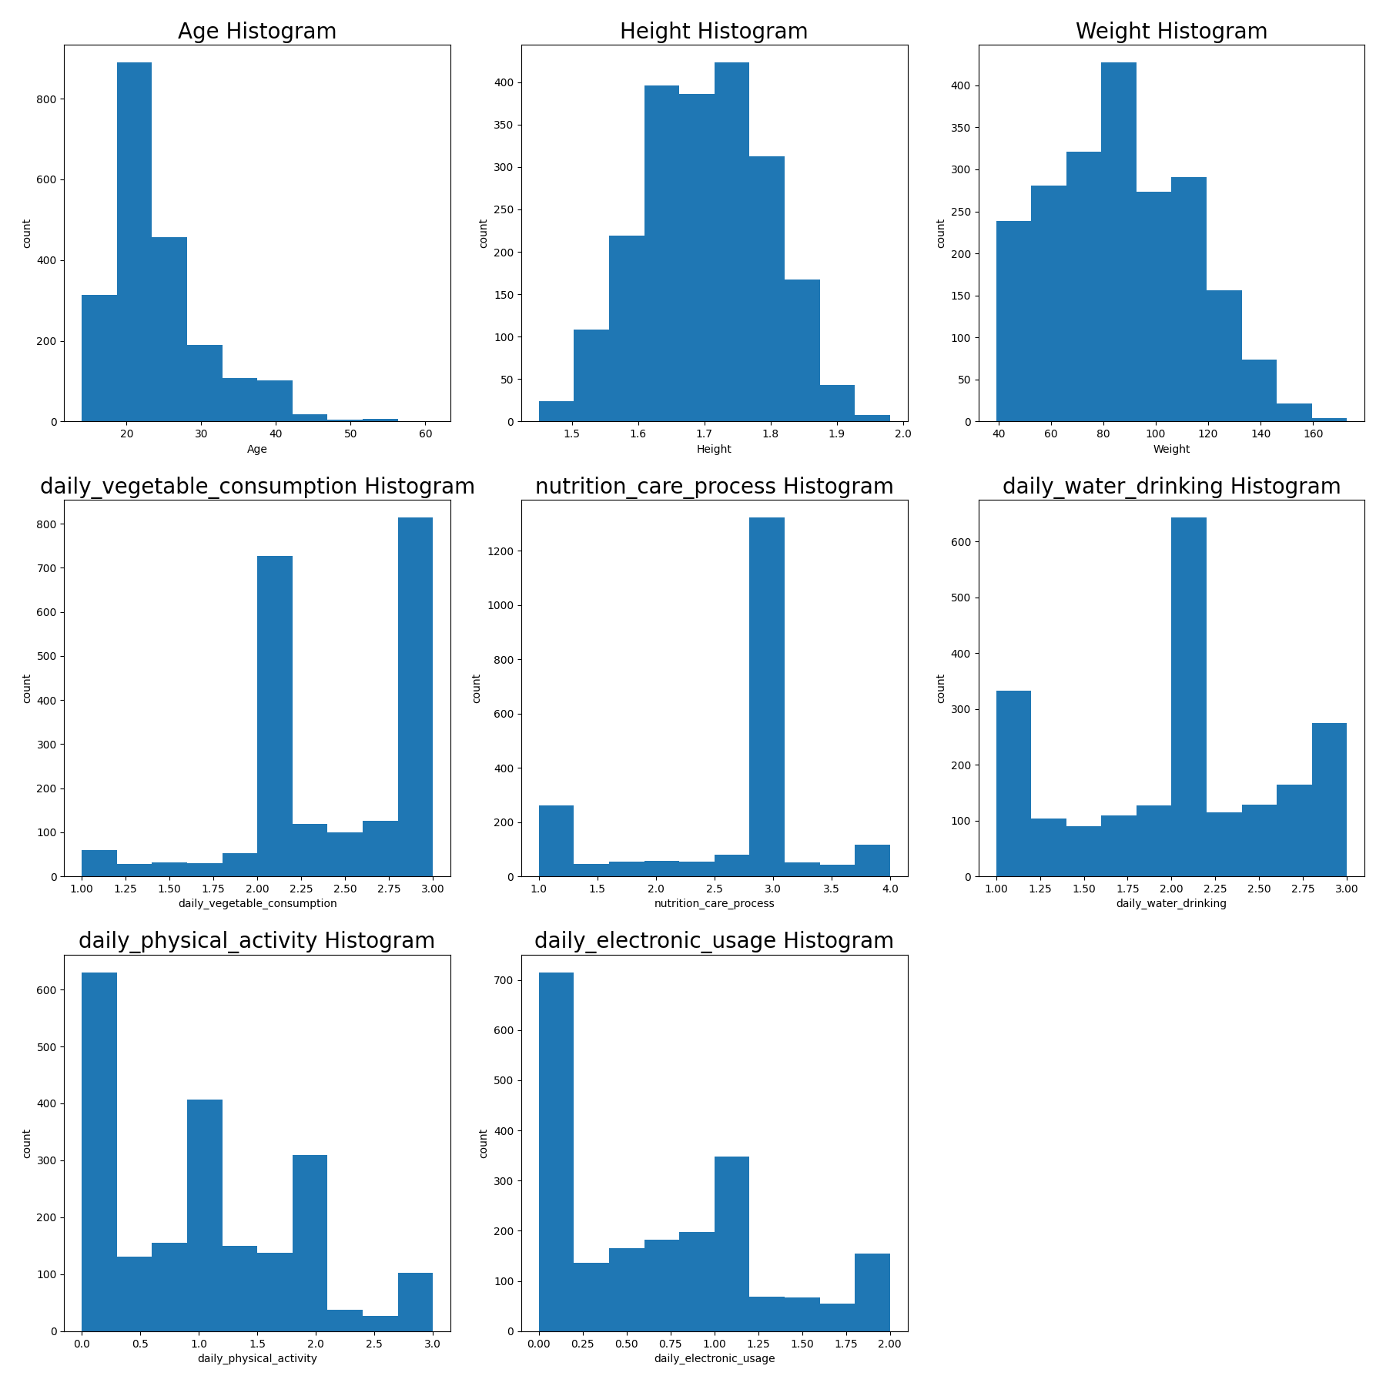

Figure 5 showcases us the categorical columns. Instantly we can see that most of the categories are binary meaning values can be classified in only 2 categories. The following categorical columns food_between_meals, freq_alcohol_usage, transportation_method, and our target variable obesity_status have more than 2 categories we can further visit its relationship to potential feature candidates.
Figure 5 Bar plot of categorical columns
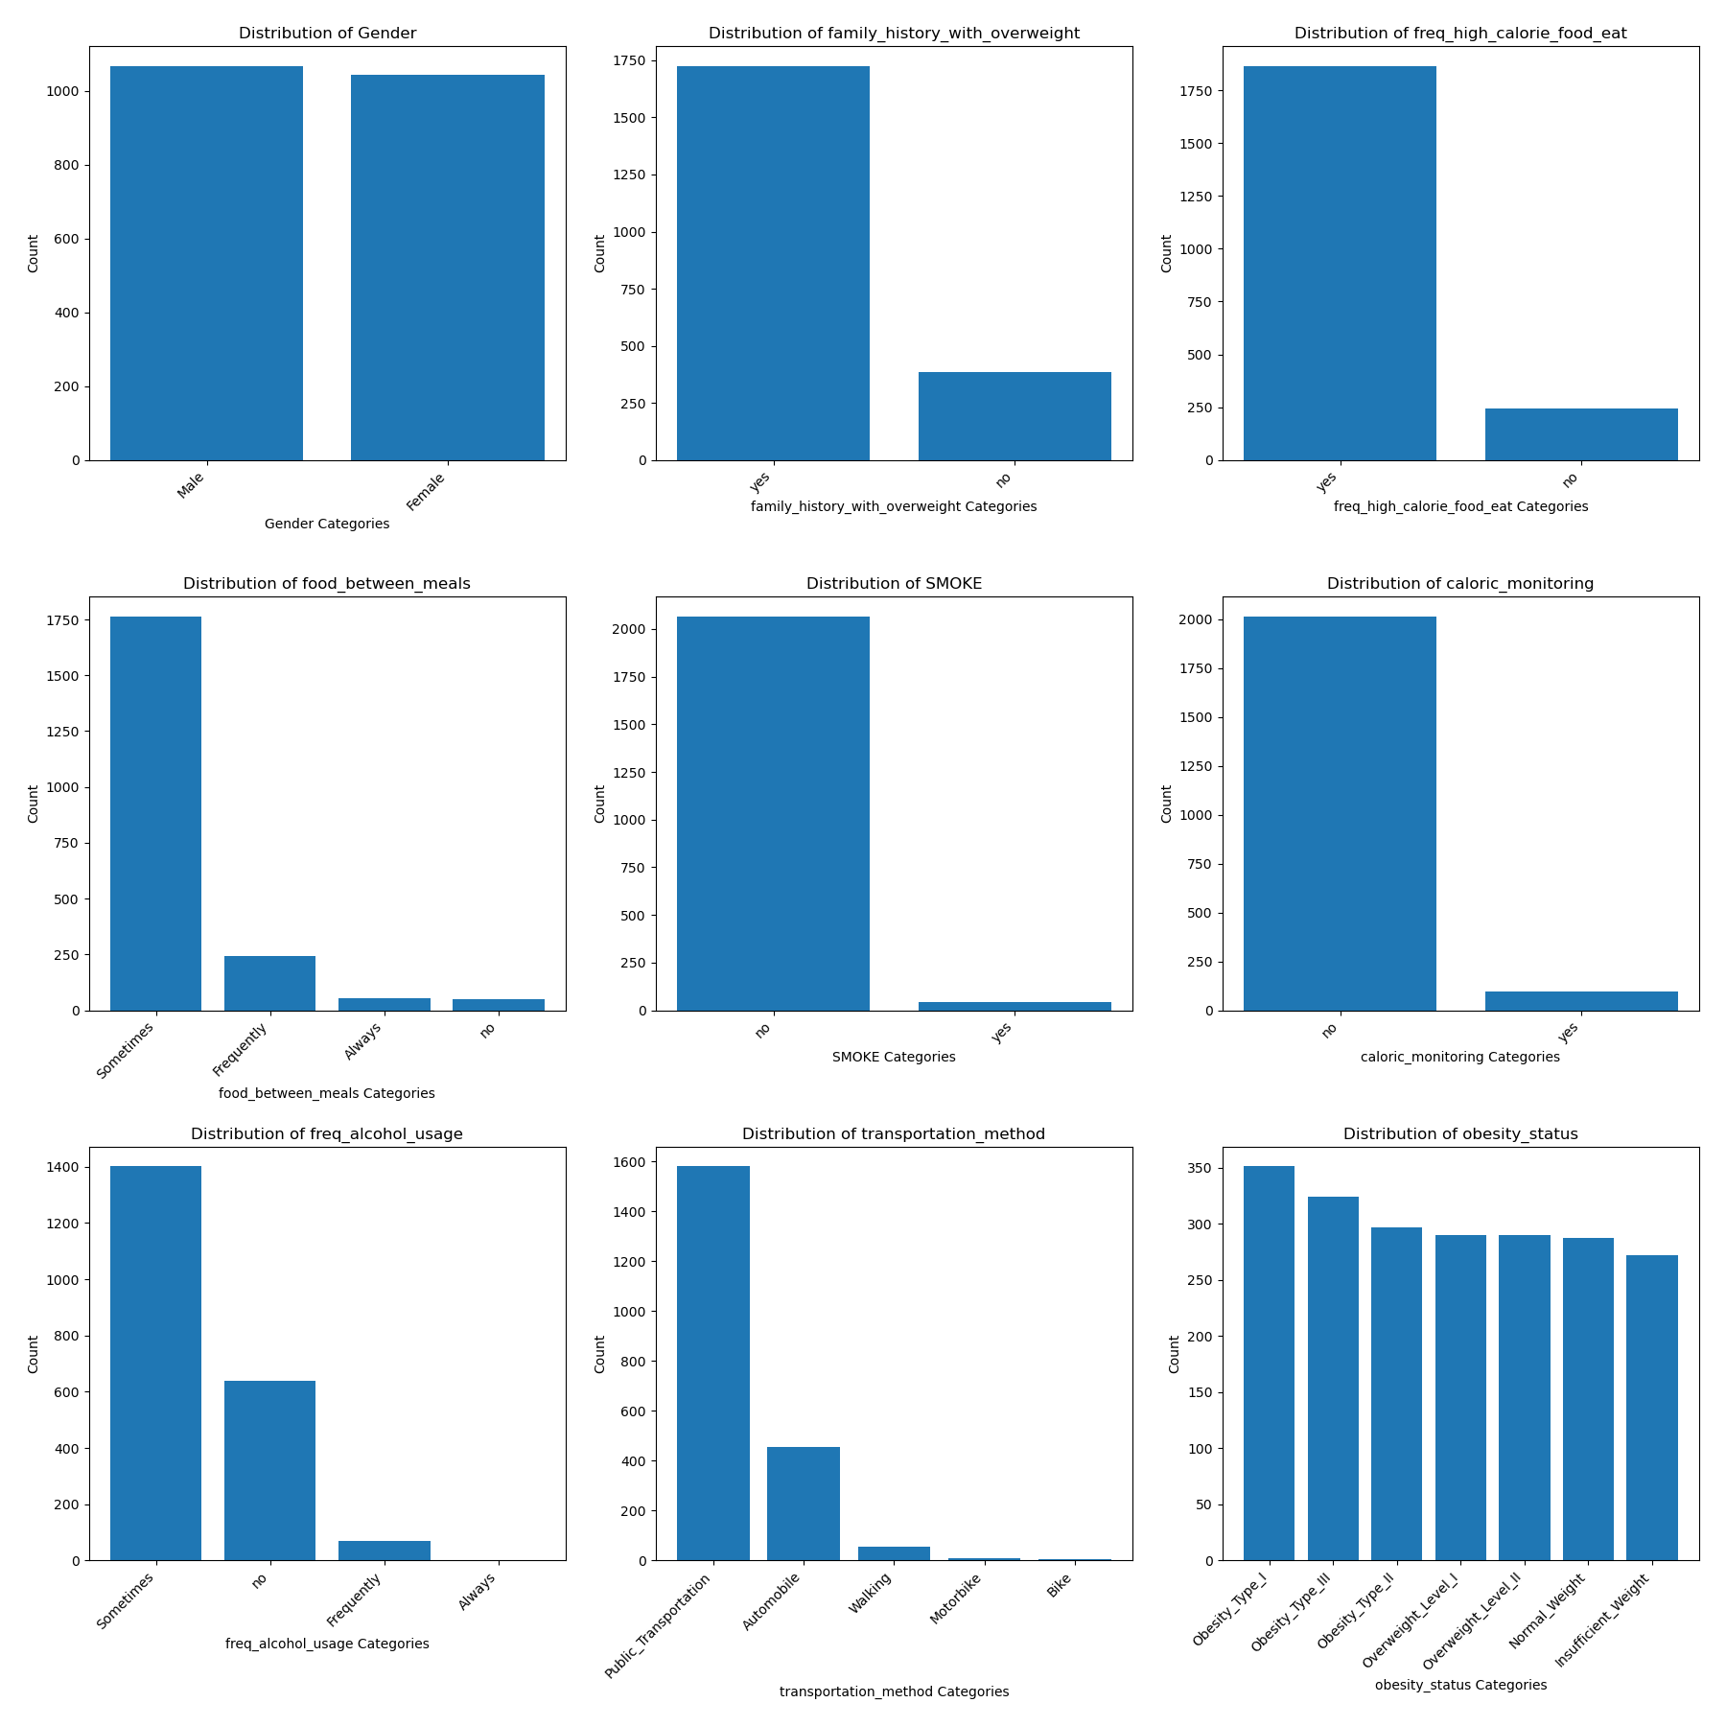

Multivariate Column Analysis
In this segment we will be analyzing the relationships between our target variable and from all the columns. Before we move forward, we will be analyzing Figure 6 heatmap to identify which columns are significant based on the strong colour of the column. From what we can see here there are 4 columns that spark interest. These are Weight, family_history_with_overweight, Age, daily_water_drinking and food_between_meals. These are our most significant variables.
It is also evident that the height column has strong correlations to the gender and weight column. We will further explore the relationship of this data and determine how it can relate to our target variable.
Figure 6 Correlation heatmap
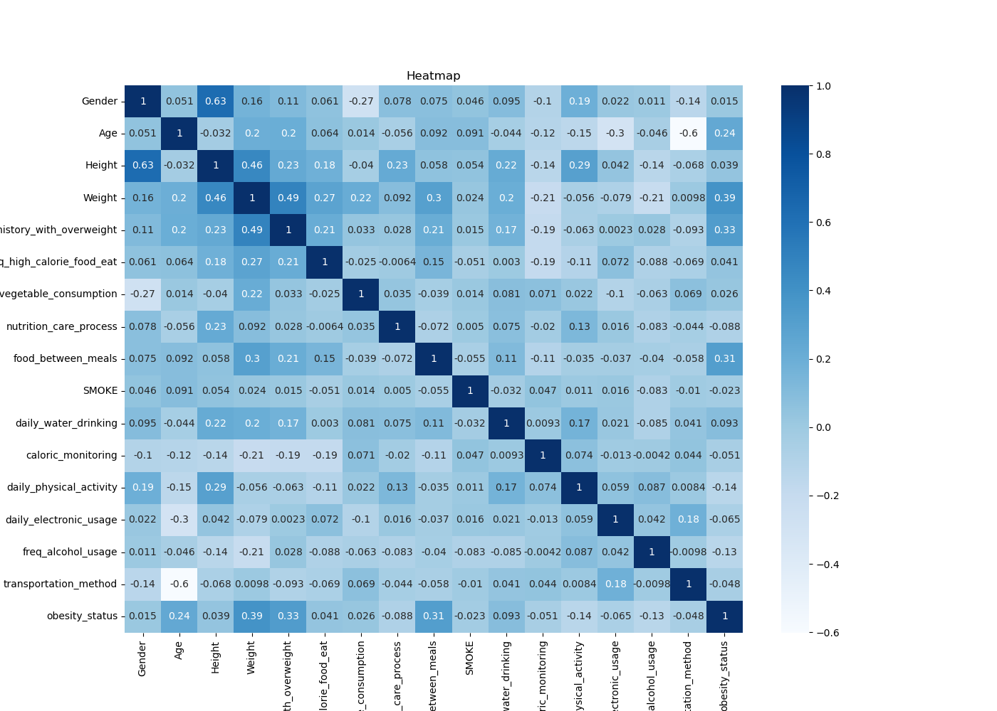

Figure 7 showcases the relationship with a person’s obesity status and the numerical candidates. Here we can see that weight seems to play a key role in a person’s obesity. The relationship indicates that the increase of weight increases the obesity status of a person. The age boxplot shows us multiple outliers within the dataset. We can also see that daily_water_drinking feature seems to have no correlation with the obesity status although it show us the spread of the data is quite large indicating inconsistency.
Figure 7 Obesity status vs numerical candidates’ boxplot
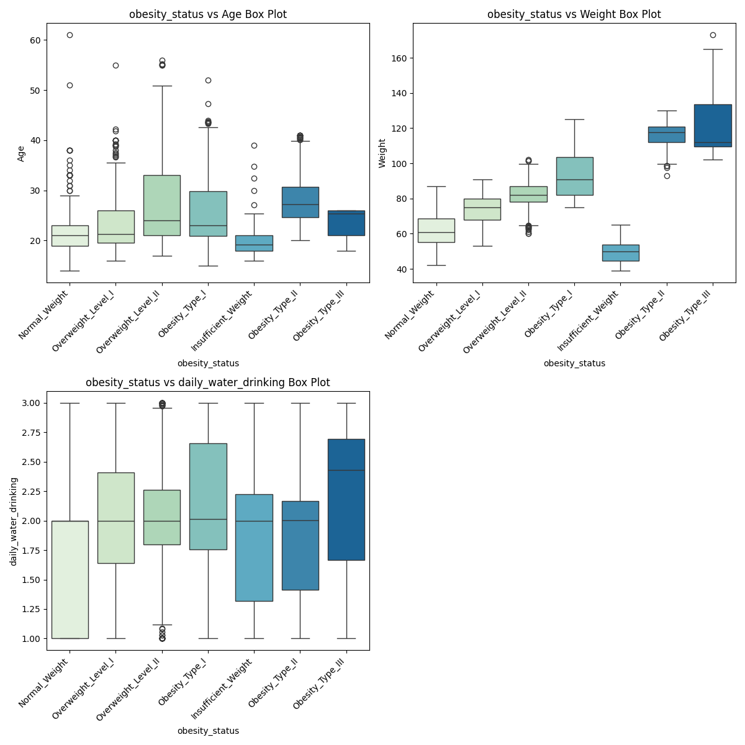

Figure 8 further explores our numerical candidates by showing us the distribution of the data. Here we can see that Weights relationship with obesity status is strong as not only the distribution of data grows larger but is consistent within each category. The daily_drinking_water feature further shows the inconsistency of the data with how long the distribution is. The Age feature also further explores the outliers with the sharp tips indicating it drags the data further out creating inconsistencies.
Figure 8 Obesity status vs numerical candidates’ violin plots
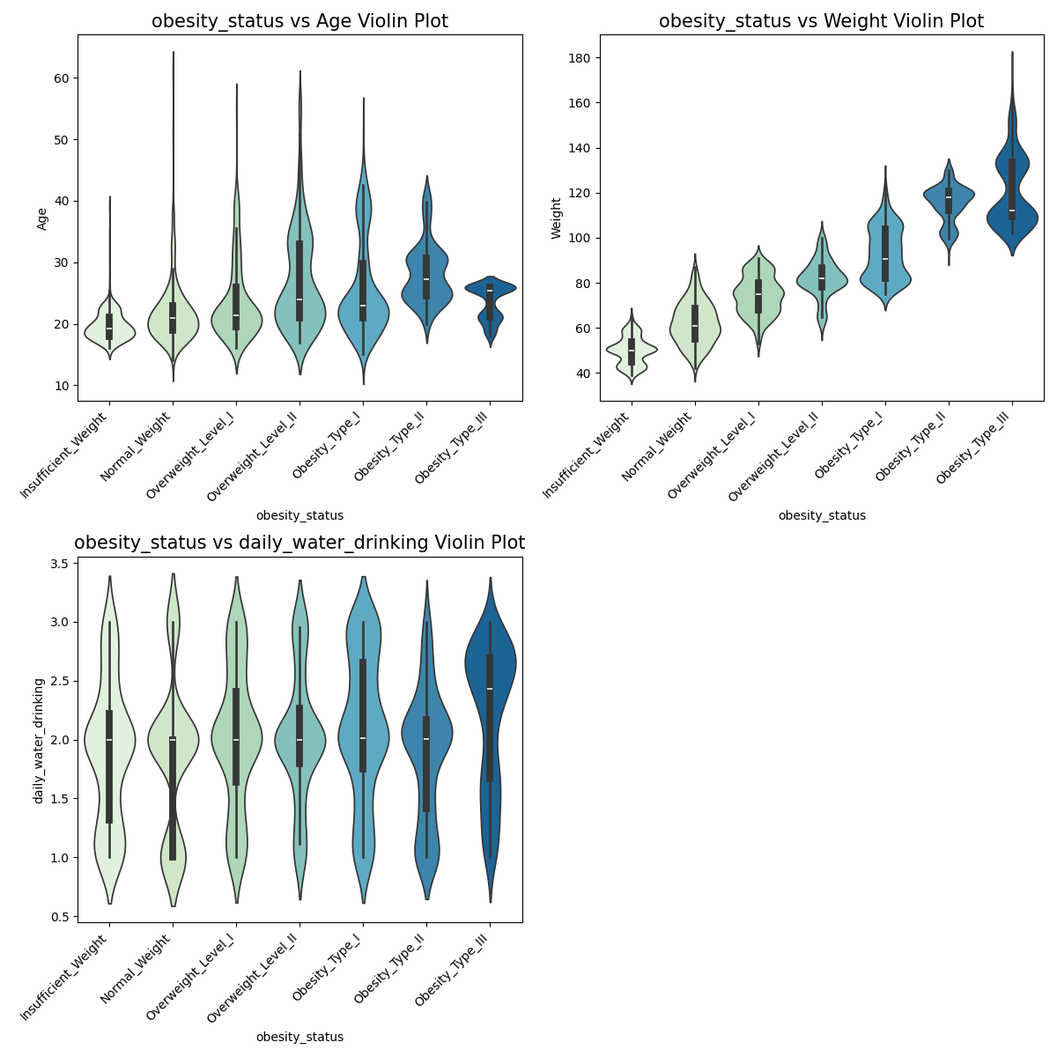

Figure 9 shows us obesity status vs our categorical candidates. On the left the food_between_meals feature showcases us the most prominent category that effects a person’s obesity but does not show a pattern. This indicates that the value “sometimes” is more dominant and shows an imbalance of data points. On the right we can clearly see a pattern with the family_history_with_overweight feature. Those with a family history with overweight increase as the obesity type increases. Furthermore, the higher the level of obesity goes the number of people with no family history of overweight decreases.
Figure 9 Obesity status vs categorical candidates count plot
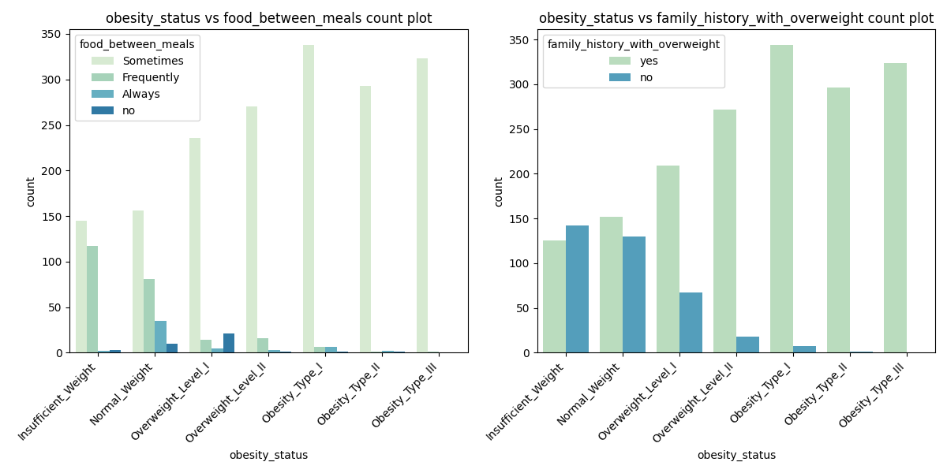
Figure 10 further explores height as it has a high correlation with weight. By the scatter plot we can see that there is a strong relationship between height and weight. As height increases, weight increases. We can also see how the relationship between height and weight play a role in obesity status. You can see that by obesity III (pink) the weight, and height increases significantly faster and it gets slower the further back down we get until the person is considered insignificant in weight.
Figure 10 Height vs weight relationship to obesity status scatterplot
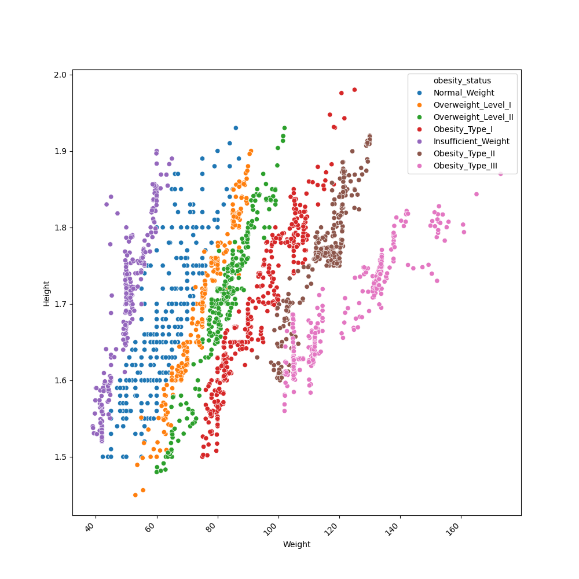

Model Feature Selection + Evaluation
After performing and EDA we had concluded that our best numerical candidates are Weight and Height, and our best categorical candidates are family history with overweight. The Age, daily_drinking_water, and food_between_meals had issues that can cause errors in our results but to better understand which feature have importance a simple mean importance feature check is done. To do this we preprocessed our data and separated categorical features into their own features which we can see by our 4th feature.
Figure 11 shows us our top 5 features based on an average of results between multiple classification models. From our EDA and importance check we have overlapping features. Weight, Height, and Age. We also have two new features Gender_Female and daily_vegetable_consumption. Since these features are based on importance in model testing, we will be using these in our model evaluation for all models used.
Figure 11 Top 5 mean importance features
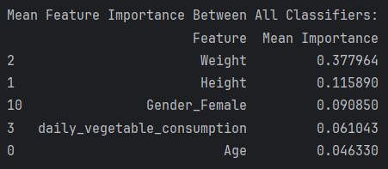
After extensive model testing, we came up with our top 6 models, each reliably tested over multiple subsets. To gain a robust and reliable insight into how well the models perform after testing in multiple subsets we added a second layer of validated accuracy. Below is a short explanation of the table.

The mean and standard deviation accuracy. It is an average accuracy between multiple runs with a single model where the data is split into subsets. Its test’s reliability and consistency. Validated Accuracy is a second layer to validate the results of our model after reliable testing as a second layer of validation. Lastly Testing accuracy indicates how well the model predicts based on data it has never seen before.

Table 1 Model Evaluation
Classifiers | Feature Selection | Mean Accuracy | Mean Std Accuracy | Validated Accuracy | Testing Accuracy
Bagged Decision Tree | Weight, Height,  Gender_Female, Age, daily_vegetable_consumption | 0.9481 | 0.0162 | 0.9424 | 0.9569
KNN Neighbors | Weight, Height,  Gender_Female, Age, daily_vegetable_consumption | 0.8458 | 0.0291 | 0.8705 | 0.9019
Light GBM | Weight, Height,  Gender_Female, Age, daily_vegetable_consumption | 0.9537 | 0.0078 | 0.9664 | 0.9665
Ensemble Vote | Weight, Height,  Gender_Female, Age, daily_vegetable_consumption | 0.9617 | 0.0142 | 0.9568 | 0.9809
Logistic Regressor | Weight, Height,  Gender_Female, Age, daily_vegetable_consumption | 0.6709 | 0.0298 | 0.6595 | 0.7177
Stacked Model | Weight, Height,  Gender_Female, Age, daily_vegetable_consumption | 0.9553 | 0.0064 | 0.9522 | 0.9688

Model Choice + Conclusion
Based on the accuracy results of table 1, the Ensemble Vote model is the most reliable in terms of running it in multiple subsets with a value of 0.9617 or 96.17% accurate. It also has the highest accuracy when predicted with unseen data with a value of 0.9809 or 98.09%. Below is the combination of models used to create the ensemble vote as well as its chosen parameters.

For further improvements in the future, we can consider treating outliers for a consistent spread of data, and if time permits an extensive look into the best combinations of models as well as combination of parameters may help in increasing the accuracy to 99%.

